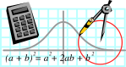  Rossmoyne SHS  Mathematics  Department | MATHEMATICS  2CD MAT | Semester 1 2011  EXAMINATION

NAME:
TEACHER: Belonogoff Fletcher Longley
Pui Tay

Marking Guide
Section Two:
Calculator-assumed

Time allowed for this section
Reading time before commencing work: 10 minutes
Working time for this section: 100 minutes

Materials required/recommended for this section

To be provided by the supervisor
This Question/Answer Booklet
Formula Sheet (retained from Section One)

To be provided by the candidate
Standard items: pens, pencils, pencil sharpener, eraser, correction fluid, ruler, highlighters

Special items: drawing instruments, templates, notes on two unfolded sheets of A4 paper, and up to three calculators satisfying the conditions set by the Curriculum Council for this examination

Important note to candidates
No other items may be taken into the examination room. It is your responsibility to ensure that you do not have any unauthorised notes or other items of a non-personal nature in the examination room. If you have any unauthorised material with you, hand it to the supervisor before reading any further.
Structure of this paper

Section | Number of questions available | Number of questions to be answered | Suggested working time  (minutes) | Marks  available
Section One:  Calculator-free | 9 | 9 | 50 | 40
Section Two:  Calculator-assumed | 17 | 17 | 100 | 80
 |  |  |  | 120

Instructions to candidates

- The rules for the conduct of Western Australian external examinations are detailed in the Year 12 Information Handbook 2010. Sitting this examination implies that you agree to abide by these rules.

2. Answer the questions according to the following instructions.

Section Two: Write answers in this Question/Answer Booklet. All questions should be answered.
Show all your working clearly. Your working should be in sufficient detail to allow your answers to be checked readily and for marks to be awarded for reasoning. Incorrect answers given without supporting reasoning cannot be allocated any marks. For any question or part question worth more than two marks, valid working or justification is required to receive full marks. If you repeat an answer to any question, ensure that you cancel the answer you do not wish to have marked.
It is recommended that you do not use pencil except in diagrams.

3. You must be careful to confine your responses to the specific questions asked and to follow any instructions that are specific to a particular question.

- Spare pages are included at the end of this booklet. They can be used for planning your responses and/or as additional space if required to continue an answer.
  - Planning: If you use the spare pages for planning, indicate this clearly at the top of the page.
  - Continuing an answer: If you need to use the space to continue an answer, indicate in the original answer space where the answer is continued, i.e. give the page number. Fill in the number of the question(s) that you are continuing to answer at the top of the page.

QUESTION | MARKS AVAILABLE | STUDENT MARK
10 | 7
11 | 5
12 | 4
13 | 7
14 | 4
15 | 5
16 | 5
17 | 2
18 | 3
19 | 4
20 | 5
21 | 2
22 | 8
23 | 5
24 | 4
25 | 5
26 | 5
TOTAL | 80
10. [7 marks}

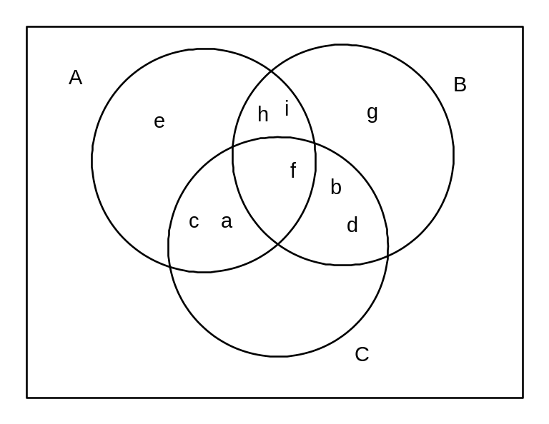
Find the following for the information displayed in the Venn diagram:

{g} 
(a) (A ∪ C)′ …………….

_ 3 
(b) |B ∩ C| …………….

{a,c,e} 
(c) B′ …………….

φ or {} 
(d) (A ∪ B ∪ C)′ …………….

State whether the following are true (T) or false (F).

F 
(e) {a, c, i} ∈A …………….

T 
(f) U = C ∪ C' …………….

T 
(g) (B ∩ C) ⊂ B …………….

11. [5 marks]
______
Two sets are such that n(M) = 46, n(R) = 58, n(U) = 96, n(M ∪ R) = 8
Complete the following Venn diagram using this information, showing the total in each section.
given  calculated 

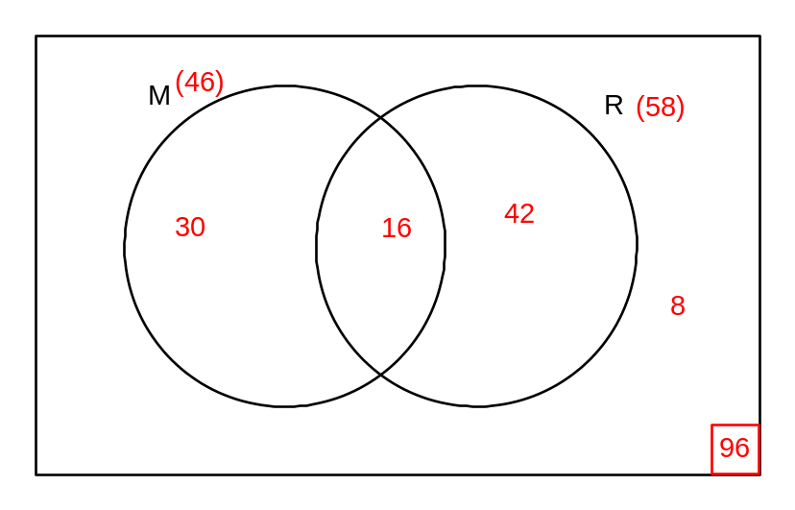
Find the following, giving answers as decimals correct to 2 dp.

0.31 
(a) P(M ∩ R') …………………..

0.35 
(b) P(R | M) ………………….

0.92 
(c) P(M ∪ R) ………………….

12. [4 marks]

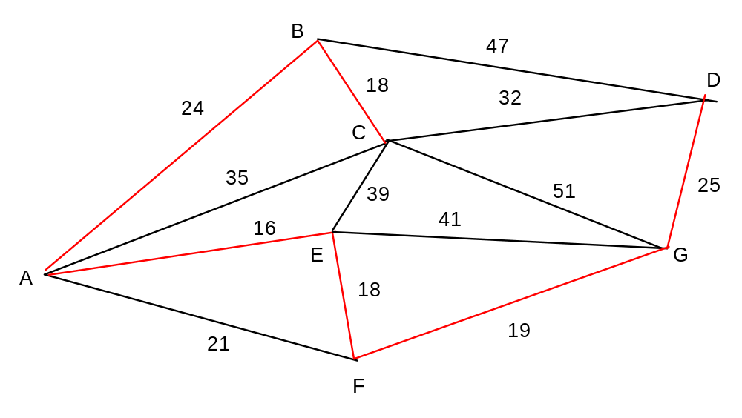

The diagram shows the distance in kms between several neighbouring towns which are to be
connected to the national broadband network.

Determine a minimal spanning tree that will connect all towns and illustrate the connections
clearly on the diagram.



What is the total length of cabling required to connect all towns to the network in the minimal
configuration?

24 + 18 + 16 + 18 + 19 + 25 = 120km 
………………

What is the length of cabling installed between C and E?

24 + 18 + 16 = 58 km 
………………

13. [7 marks]

The following networks represent an irrigation network between a number of farms.
The values shown represent the carrying capacity in 1000s of litres per hour.

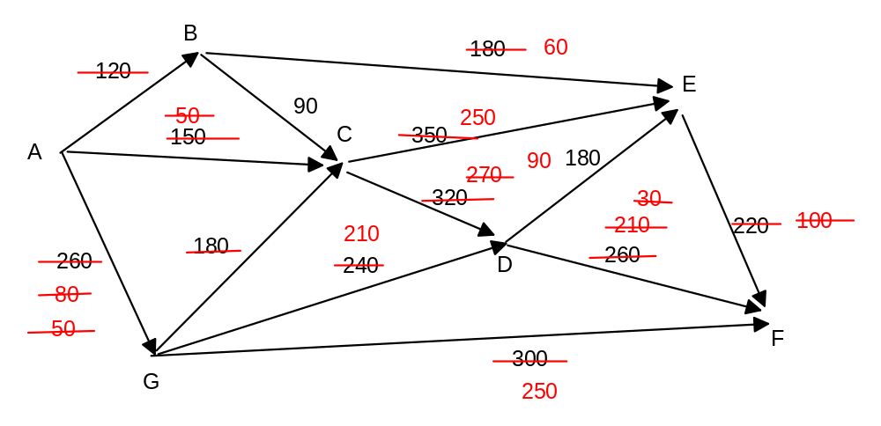
A 
(a) Name the source for the network ………………….

F 
(b) Name the sink for the network ………………….

(c) Determine the maximal flow for the network showing clearly your working
diagram 
ABEF 120
ACEF 100
ACDF 50 
AGCDF 180
AGDF 30
AGF 50
--------------
530 kL/hr 

14. [4 marks]

The state railway authority wishes to build a freight network linking seven towns. As the budget
is tight they need to connect the towns with the minimum amount of rail so that residents can
travel, not necessarily directly, between any of the towns to any other town.

The following table indicates the direct distances between the towns in kilometres.

 | Roydon | Bisley | Carramar | Fordes | Marrich | Prascoe | Garrem
Roydon | 0 | 203 | 512 | 128 | 292 | 341 | 218
Bisley | 203 | 0 | 224 | 100 | 205 | 196 | 159
Carramar | 512 | 224 | 0 | 205 | 324 | 161 | 182
Fordes | 128 | 100 | 205 | 0 | 361 | 131 | 285
Marrich | 292 | 205 | 324 | 361 | 0 | 361 | 194
Prascoe | 341 | 196 | 161 | 131 | 361 | 0 | 249
Garrem | 218 | 159 | 182 | 285 | 194 | 249 | 0

(a) Determine the minimum length of track required to connect the network using Prim's algorithm.
Show clearly on the table how you determined the connections to be made. 

128 + 159 + 100 + 131 + 161 + 194 = 873 km 

(b) Which towns have direct rail links to Fordes?

Roydon, Bisley, Prascoe 

15. [5 marks]

From the following tables determine whether the functions are linear, quadratic or neither. If linear or quadratic, determine the equation that defines the function.

x | 0 | 1 | 2 | 3 | 4 | 5
y | −1 | 2 | 11 | 26 | 47 | 74

Quadratic  y = 3x² − 1 
Type: …………….. Equation: …………………………..

x | 1 | 2 | 3 | 4 | 5 | 6
y | 1 | −3 | −7 | −11 | −15 | −19

Linear  y = −4x + 5 
Type: ……………. Equation: …………………………..

x | 1 | 2 | 3 | 4 | 5 | 6
y | 1 | 3 | 7 | 15 | 31 | 63

Neither 
Type: ……………. Equation: …………………………..
16. [5 marks]

Two lines are given by the equations f(x) = 3x − 4 and g(x) = 5x + 2

Find the following:

(a) The value of f(5) − g(2)

3×5 − 4 −(5×2 + 2) = −1
−1 
…………………….

(b) The point at which the 2 lines intersect.

( −3, −13) 
…………………..

(c) The equation of the line parallel to h(x) = 4x + 1 and passing through the point of intersection.

−13 = 4×−3 + b
b = −1

y = 4x − 1 
………………………

(d) The value of k given that point J(−2,k) lies on the line g(x).

k = 5×(−2) + 2
k = −8 
………………………

17. [2 marks]

I think of a number, multiply it by itself then add four times the number I first thought.
The answer I get is 32. What is the number I first thought of?

x² + 4x = 32

(x + 8)(x − 4) = 0
x = −8, 4 
……………………..

18. [3 marks]

A ping pong ball hits the table and follows a path given by h = 0.001(800d − 4d² − 14400)
where h is the height of the ping pong ball above the table in cms and d is the distance
in cms along the 274 cm table. The height of the net is 15.25cm.

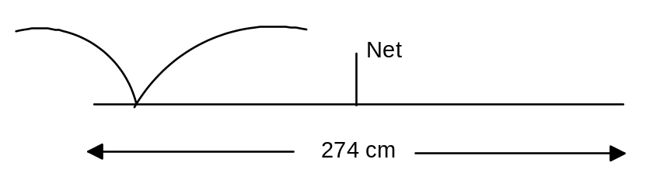

(a) Determine how far along the table the ball first hits.

20cm 
…………….

(b) What is the maximum height reached by the ball?
25.6 cm 
…………….

(c) Will the ball get over the net? Give evidence for your answer.

at d = 137cm, h = 20.124 cm… yes it will. 
…………….

19. [4 marks]

Factorise the following expressions:

x² + 5x − 24
(x + 8)(x − 3) 
…………………….

9x² − 36

(3x − 6)(3x + 6) 
………………………

Find the points of intersection between the two functions above to 2 decimal places.

(−0.95, −27.85), (1.58, −13.63) 
………………………..……………………….

20. [5 marks]

Julian invests $12 000 at 8% per annum. Determine the value of the investment after 5 years
if the investment is compounded: (give answers to the nearest dollar)

(a) annually
$17632 
……………………..

(b) quarterly
$17831 
……………………...

(c) monthly
$17878 
………………………

If, instead he had invested it at 9.5% per annum simple interest, which of the 4 investments would have given the best returns? Show evidence for your answer.

A = 12000 + 12000×0.095×5 = 17700 

8% compound interest compounded monthly 
…………………………………………………

21. [2 marks]

To the nearest cent what monthly repayment would be needed to repay a loan of $20 000
with compound interest of 6% per annum compounded monthly, if it needs to be paid off
in 6 years.
$331.46 
…………………………..

How much interest will he have paid by the time it is paid off?

331.46×72 − 20000 = 3865 
$3865
…………………………..
22. [8 marks]

The table represents heights of sunflowers in centimetres in a nursery.

Score | Frequency
30 → 34 | 12
35 → 39 | 18
40 → 44 | 23
45 → 49 | 34
50 → 54 | 28
55 → 59 | 16

45 → 49 
(a) Determine the modal group: ……………………..

46 cm 
(b) Estimate the mean for the data to nearest cm ……………………..

131 
(c) How many sunflowers were measured? ……………………..

(d) If a sunflower measuring 53 cm is added to the data how will this affect the
estimated mean? Give reasons.

will rise slightly as the value is in the group above the mean 
………………………………………………………………………………

Display this data on the grid below. Axes  Bars  bars offset 0.5 

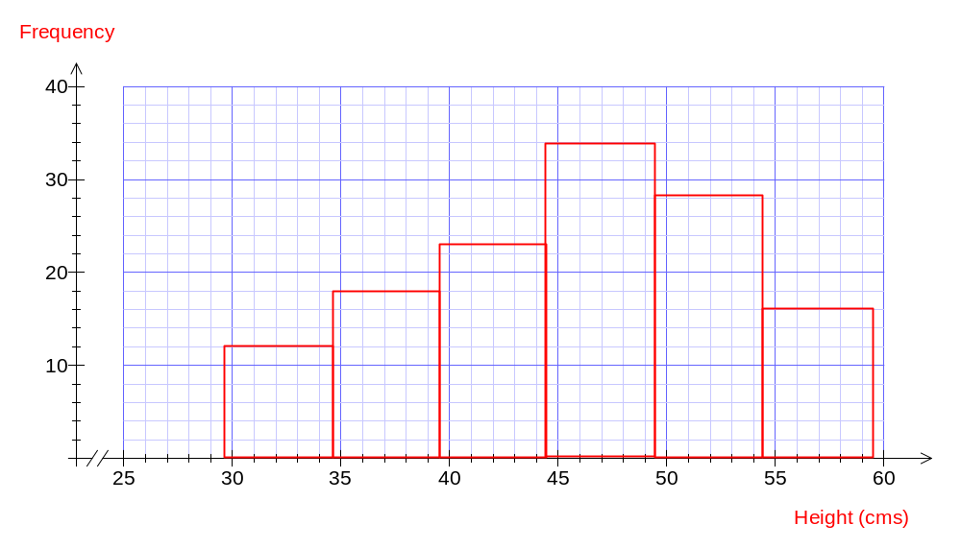

23. [5 marks]

The mean of 12 values is 46.75. If another score of 53 is added find the new mean to 2 dp.

total = 12×46.75 = 561 
mean of 13 values = (561+53)/13 = 47.23 

47.23
……………………..

The mean of a second set of 15 values is 42.31. Find the mean of the combined set of 12 values
and 15 values to 2 decimal places.

total = 15×42.31 = 634.65 P

combined = 643.65 + 561 = 1195.65

mean = 1195.65/27 = 44.28 P

24. [4 marks]

The table below gives the the number of training sessions (x) and the times in seconds on a typing test (y) for 9 students undergoing training.

x | 4 | 6 | 10 | 6 | 7 | 6 | 8 | 8 | 9
y | 9 | 10 | 4 | 11 | 7 | 7 | 8 | 10 | 5

Use your calculator to determine the line of best fit for the data.

y = −0.85x + 14 
………………………

Use this to predict the likely time (to the nearest second) for a student who has attended 5 training
sessions.

10 seconds 
………………………

Explain the meaning of the negative gradient in the line of best fit for the data.

The more training sessions the less the time taken on the test 
…………………………………………………………………………………………………

25. [5 marks]

Jack and Jill buy a house in 2011 for $530 000. Assume the value of the house keeps up with the
inflation rate of 2.5% for the first 5 years after 2011. After 2016 the inflation rate rises to 3.2%.

(a) Assuming the inflation rate remains the same after 2016 what will the house be worth in 2020 (to
nearest dollar)

530 000(1.025)⁵ ≈ 599646 in 2016 
599646(1.032)⁴ = 680164.5 ≈ 680165 

$680 165
............................

(b) What is the overall increase in value as a percentage. Give the answer to the nearest percentage.

680164.5/530000 = 1.2833
28% 
28%
............................

(c) In what year will the house be worth $1 000 000?

1 000 000 = 599646×1.032^{x}
x = 16 years
2032 
...............................

(d) If, instead, house prices rise by 1% above inflation, what would its value have been in the
year 2016 to the nearest $500

530 000 × 1.035⁵ = 629 500 
$629 500
...................................

26. [5 marks]

Taxable Income | Tax Rate | Tax Payable
$0 to $6 000 | 0% | $nil
$6 001 to $34 000 | 15% | $nil plus 15% of amount over $6 000
$34 001 to $80 000 | 30% | $4 200 plus 30% of amount over $34 000
$80 001 to $180 000 | 40% | $18 000plus 40% of amount over $80 000
$180 001+ | 45% | $58 000 plus 45% of amount over $180 000

Find to the nearest cent, the fortnightly take home pay of a man who earns $84 320.

18 000 + 4320×0.4 = 19728 tax 

(84320 − 19728)/26 = $2 484.31 
$2484.31
....................................

A tax deduction reduces the amount that he has to pay tax on, while not affecting his actual salary.
In other words, it is a tax free part of his salary.

If the same man has tax deductions of $5200, determine his new fortnightly take home pay to the
nearest cent.

84 320 − 5200 = 79 120 taxable salary 

4200 + 0.3×(79120 − 34000) = 17736 tax 

(84320 − 17736)/26 = 2560.92 
$2560.92
...........................

END SECTION TWO

